Lab Assignment 4

Controlling the 7-Segment Displays with

Object-Oriented ProgrammingTianqi Li

Email Address: li.tianq@northeastern.edu

Submit date:

Due Date: 8/5/2020

**Abstract**

In this lab, we learned how to use the 7-segment displays in the DE1-SoC board to display characters, decimal, and hexadecimal values using object oriented design in C++. The DE1-SoC has six 7-segment displays controlled by two parallel ports (HEX3, HEX2, HEX1, & HEX0) (HEX5 & HEX4). We should use these two different addresses (7-segment displays) to display the thing we wanted. And we learned how to use the makefile to make all file work.

# Introduction

In this lab, we learned how to use the 7-segment displays in the DE1-SoC board to display characters, decimal, and hexadecimal values using object oriented design in C++. The DE1-SoC has six 7-segment displays controlled by two parallel ports (HEX3, HEX2, HEX1, & HEX0) (HEX5 & HEX4). We should use these two different addresses (7-segment displays) to display the thing we wanted. And we learned how to use the makefile to make all file work.

# Lab Discussion

Computer system: Window 10

DE1-SoC board

One 32 GB Micro SD Card (Insert in DE1-SoC board)

One 64 GB USB flash drive (write with the Win32DiskImager)

# Results and Analysis

|  |  |  |  |  |  |  |  |  |  |
| --- | --- | --- | --- | --- | --- | --- | --- | --- | --- |
| Character | OUTPUTS - Segment 0/1 | | | | | | |  |  |
| # | 6 | 5 | 4 | 3 | 2 | 1 | 0 | Decimal | Hex |
| 0 | 0 | 1 | 1 | 1 | 1 | 1 | 1 | 63 | 0x3F |
| 1 | 0 | 0 | 0 | 0 | 1 | 1 | 0 | 6 | 0x6 |
| 2 | 1 | 0 | 1 | 1 | 0 | 1 | 1 | 91 | 0x5b |
| 3 | 1 | 0 | 0 | 1 | 1 | 1 | 1 | 78 | 0x4E |
| 4 | 1 | 1 | 0 | 0 | 1 | 1 | 0 | 102 | 0x66 |
| 5 | 1 | 1 | 0 | 1 | 1 | 0 | 1 | 109 | 0x6d |
| 6 | 1 | 1 | 1 | 1 | 1 | 0 | 1 | 125 | 0x7d |
| 7 | 0 | 0 | 0 | 0 | 1 | 1 | 1 | 7 | 0x7 |
| 8 | 1 | 1 | 1 | 1 | 1 | 1 | 1 | 127 | 0x7E |
| 9 | 1 | 1 | 0 | 1 | 1 | 1 | 1 | 111 | 0x6F |
| A (10) | 1 | 1 | 1 | 0 | 1 | 1 | 1 | 119 | 0x77 |
| b (11) | 1 | 1 | 1 | 1 | 1 | 0 | 0 | 124 | 0x7c |
| C (12) | 0 | 1 | 1 | 1 | 0 | 0 | 1 | 57 | 0x39 |
| d (13) | 1 | 0 | 1 | 1 | 1 | 1 | 0 | 94 | 0x5E |
| E (14) | 1 | 1 | 1 | 1 | 0 | 0 | 1 | 121 | 0x79 |
| F (15) | 1 | 1 | 1 | 0 | 0 | 0 | 1 | 113 | 0x71 |

This form was created in pre-lab.

**Assigemnt 1**

All the DE1SoChps code is in the **lab4.zip** and **lab4b.zip**

# Assigment 2

We created SevenSegment.h and .cpp and run the given main.cpp

The terminal running output is in here, the 7-segment displays output will show on a video (the one has 53 s)

The code file is in the lab4.zip

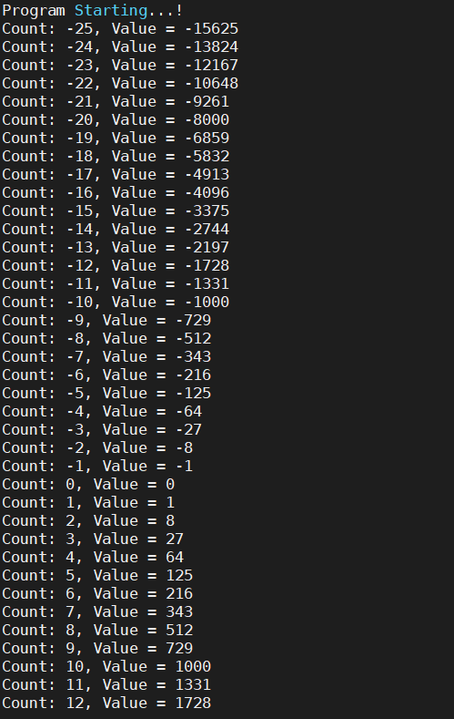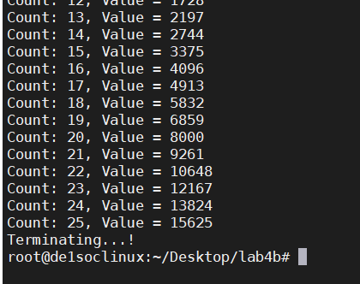

# Assigment 3

We created LEDControl.h and .cpp and change the makefile and main.cpp for run LEDControl and SevenSegment in same time.

The terminal running output is in here, the Led and 7-segment displays output will show on a video (the one has 33 s)

The code file is in the lab4b.zip

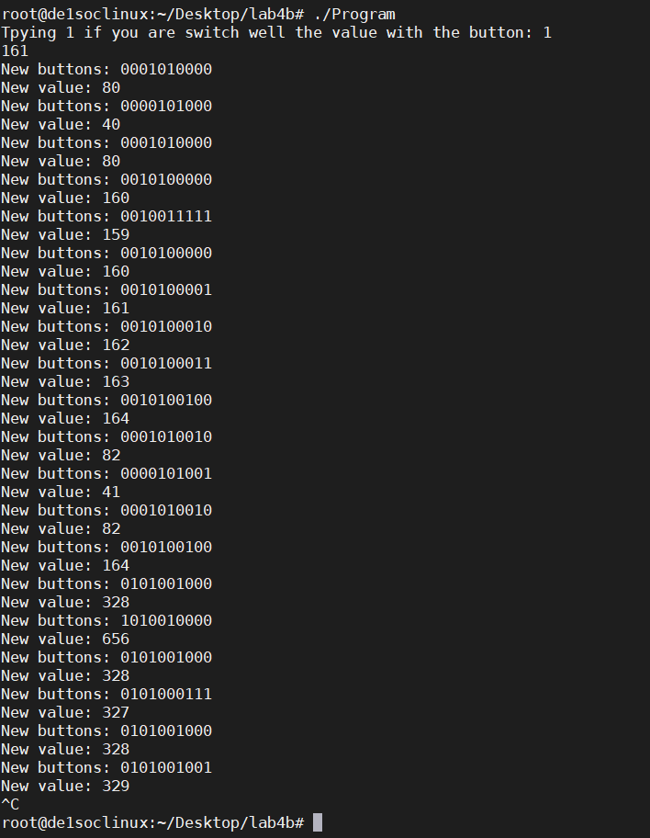

# Conclusion

In this lab, we learned how to use the 7-segment displays in the DE1-SoC board to display characters, decimal, and hexadecimal values using object oriented design in C++. And we learned how to use the makefile to make all file work.

# References

1. Michael Benjamin, “*Lab Report Guide*”, Northeastern University, January 18 2006.